Arts and Leisure

The New York TImes

Using Shakespeare to Ease the Trauma of War
By LAURA COLLINS-HUGHES MARCH 9, 2017
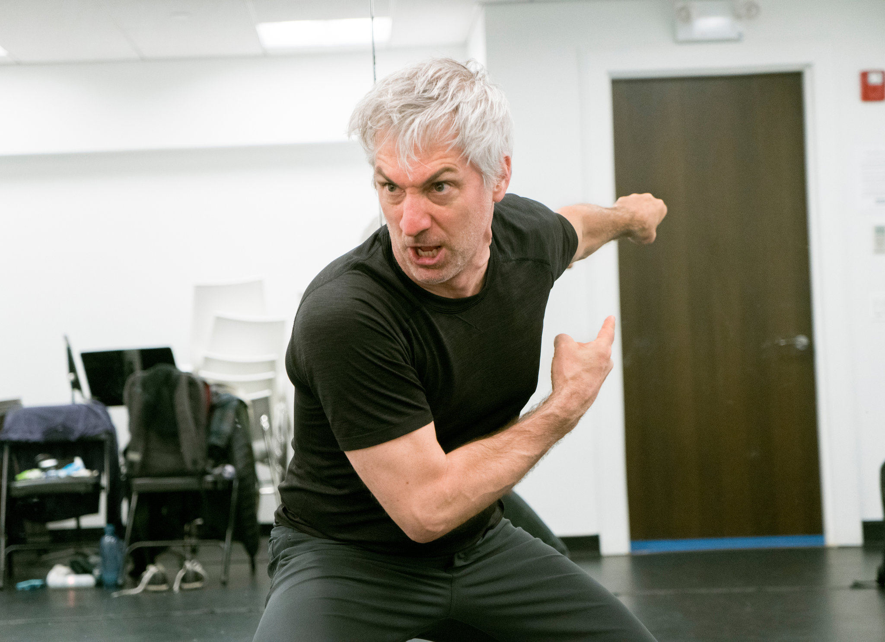
Stephan Wolfert rehearsing his one-man show, “Cry Havoc!” CreditSara Krulwich/The New York Times

Stephan Wolfert was drunk when he hopped off an Amtrak train somewhere in Montana, toting a rucksack of clothes and a cooler stocked with ice, peanut butter, bread and Miller High Life — bottles, not cans. It was 1991, he was 24, and he had recently seen his best friend fatally wounded in a military training exercise.
His mind in need of a salve, he went to a play: “Richard III,” the story of a king who was also a soldier. In Shakespeare’s words, he heard an echo of his own experience, and though he had been raised to believe that being a tough guy was the only way to be a man, something cracked open inside him.
“I was sobbing,” Mr. Wolfert, now 50 and an actor, said recently over coffee in Chelsea. “I didn’t know you could have emotions out loud.”
That road-to-Damascus moment — not coming to Jesus, but coming to Shakespeare — is part of the story that Mr. Wolfert tells in his solo show, “Cry Havoc!,” which starts performances Wednesday, March 15, at the New Ohio Theater. Taking its title from Mark Antony’s speech over the slain Caesar in “Julius Caesar,” it intercuts Mr. Wolfert’s own memories with text borrowed from Shakespeare. Decoupling those lines from their plays, Mr. Wolfert uses them to explore strength and duty, bravery and trauma, examining what it is to be in the military and what it is to carry that experience back into civilian life.
“Cry Havoc!” is being produced by the Off Broadway company Bedlam, praised for its spare and nimble stagings of plays like “Saint Joan” and “Sense & Sensibility.” The company also has an outreach program for veterans led by Mr. Wolfert. But both Mr. Wolfert and Eric Tucker, Bedlam’s artistic director, agree that this show must succeed as theater for the audience, not just as therapy for the actor.
“One-person shows, come on, those are like hit or miss — and mostly miss,” said Mr. Tucker, the director of “Cry Havoc!” who’s known Mr. Wolfert since their days in graduate school at Trinity Rep Conservatory. “We’re not just doing this as a vet outreach thing. I’m not doing it to put my friend onstage. If it wasn’t good, I wouldn’t put it up.”
A master of self-deprecation, Mr. Wolfert recalled the time several years ago, when he was still living in Los Angeles, that he performed an early version of the show for Mr. Tucker. When Mr. Wolfert finished, the director was distinctly unimpressed.
“He goes, ‘Well, you certainly had a lot of emotions, but I didn’t,’” Mr. Wolfert said, laughing.
Mr. Tucker told him he needed to be honest with the audience — to show that he was a mess of a human being, not hide behind humor and pretend he was doing fine. So Mr. Wolfert gathered his courage, and they set to work to fix it.
Stephan Wolfert, right, at the Sheen Center with his acting class made up of veterans.CreditNina Westervelt for The New York Times

Joining Up, Getting Out
You can’t hear his accent anymore — that’s how diligently he has labored to erase it — but Mr. Wolfert grew up in La Crosse, Wis., on the Mississippi River, where the locals sound like cousins to Frances McDormand in “Fargo.” A sensitive little boy in a working-class family, he yearned to perform, especially to dance. Fearing ridicule, he took up martial arts instead.
After high school, he joined the Minnesota National Guard. Recruited for officer training, he stayed in the service for seven years, until 1993. When the first Persian Gulf war began, he was activated but not sent. He did spend time, though, with the School of the Americas, a military training institute at Fort Benning, Ga.
Along the way, even before his best friend was killed, accidentally shot in a nighttime exercise at the Army’s National Training Center in California, he began to question what he was doing, and to recoil at the notion that there is always glory in sacrificing one’s life for one’s country. “Honor,” he scoffed, and noted Falstaff’s speech on the topic from “Henry IV, Part I” — a highlight of “Cry Havoc!” for him.
“Can honor set to a leg?” Falstaff asks. “No. Or an arm? No. Or take away the grief of a wound? No. Honor hath no skill in surgery, then? No.”
As he and Mr. Tucker, a veteran of the Navy Reserve, have reshaped “Cry Havoc!” for New York, Mr. Wolfert has been thinking of adding Wilfred Owen’s World War I poem “Dulce et Decorum Est,” which describes in ghastly detail a man dying in action. “I struggle to read the thing and not sob,” Mr. Wolfert said.
He knows how it feels to be repelled by a war, even adamantly opposed to it, and to be simultaneously tempted to join the fight.
“I disagreed with both the Iraq and Afghanistan invasions, and yet when they extended the age to 40, I examined re-enlisting,” he said. “I felt like, I don’t agree, but if we’re going to be there, I should be there. Maybe I can save more lives — somehow? Look at the hubris in that. But that’s what went through my head.”
His back rebelled, though, when he strapped on a 65-pound rucksack and went for a run. “The cold, hard reality is I was a nondeployable asset,” he said. “I wasn’t going to do anyone any good.”
Stephan Wolfert and his acting class that’s made up of veterans. CreditNina Westervelt for The New York Times

Mr. Wolfert worked with veterans in his own theater company during his decade in Los Angeles and has had supporting roles in Bedlam productions since moving to Brooklyn in 2013 with his wife, Dawn Stern, a former actress.
“Cry Havoc!,” which he has performed in various incarnations since 2012, puts him in the spotlight alone — laying bare his fragility, just as Mr. Tucker urged. Fixing the show meant rebalancing it, making the narration strong enough — and candid enough — to stand alongside the Shakespeare.
This time, though, Mr. Wolfert seeks something new. Sober for four years, and happy, he is determined not to let other people’s opinions dictate his behavior anymore. Yet a part of him hungers to know how he measures up, doing Shakespeare in New York.
Bottom of Form
“Do I deserve to be in the big leagues as an actor?” he asked.
It’s a vulnerable question. But he is more eager than afraid to find out.

Healing and Dealing
On a Monday night in early February, in an upstairs room at the Sheen Center on Bleecker Street, nearly 20 people gathered in a circle of chairs. This was Bedlam’s free, weekly veterans-only acting class, a place where healing and dealing are at least as important as the art.
The students are a multigenerational range of ranks and service branches, mostly men with a sprinkling of women. (A weekly Tuesday night class exclusively for female veterans, a more recent and as yet unfunded addition to the program, will go on hiatus during “Cry Havoc!”)
Mr. Wolfert tries to keep the stress low: There is no apologizing for anything, no raising of hands to speak, no scene-study-style critique of anyone’s performance.
Not all of these veterans are pursuing acting careers, but Chris Walker is. A strapping former Marine captain who served in Afghanistan, he stepped to the center of the circle when Mr. Wolfert asked for a volunteer to do a monologue.
Mr. Walker, 30, delivered a speech from “Macbeth” that he had been practicing for a month — the “If it were done when ’tis done” soliloquy, Macbeth’s debate with himself about whether to kill Duncan, the king. The class isn’t about performing Shakespeare’s plays; as in “Cry Havoc!,” Mr. Wolfert is interested in how a given monologue might resonate with a veteran, not what it means in its original context.
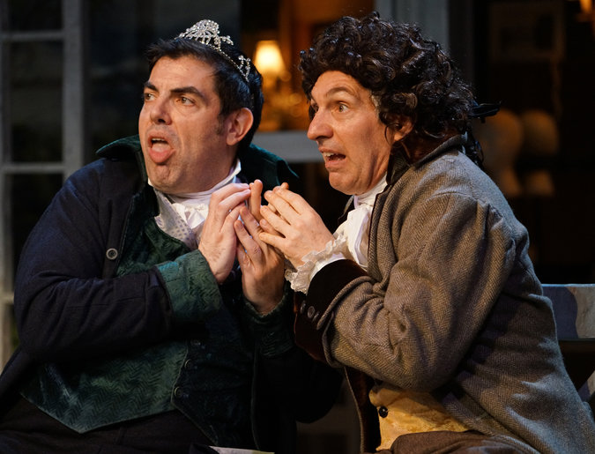
Jason O’Connell, left, and Stephan Wolfert in a Bedlam production of “Sense & Sensibility.”CreditSara Krulwich/The New York Times

So as he led Mr. Walker through line reading after line reading, Mr. Wolfert gently but persistently asked him to think about what Macbeth, who’s experienced in war, is considering: killing someone in civilian life.
“We don’t kill people off the battlefield,” Mr. Wolfert said, and the conversation tripped from the text to real life. Speaking softly and with palpable anguish, Mr. Walker recounted a physical fight this winter that he didn’t start and didn’t want, in which he tried hard not to hurt his attacker even as someone goaded him from the sidelines to do what he was trained to do.
“Suddenly I was in adrenaline mode, and I hadn’t felt like that since the last time I had killed somebody,” Mr. Walker said. “It felt invasive and wrong. It’s not supposed to be like that at home.”
“Right. Right!” Mr. Wolfert said, and downshifted his excitement into soothing assurances of safety. “We’ve got you. You can leave this exercise at any time. All right?”
“Yeah,” Mr. Walker said.
“But just to explore it, can you do whatever it takes to get into that moment, that conflict that you just described?”
Mr. Walker paused for several beats, and when he dived once more into the monologue, the difference was extraordinary. His breathing was slower and more intense, his voice more powerful yet edged with a quaver. Afterward, he explained that he was thinking as he spoke about making a different choice in that fight: hurting the other guy.
To Mr. Wolfert, who teaches controlled methods of accessing charged memories, the need to retool a lethal skill set for civilian life is a vital task that the military leaves people to figure out on their own.
“That’s something that we hold uniquely, I think, as veterans,” he told the class. “We know what we’re capable of — even for the so-called peacetime or Cold War vets. The training’s still there. And I don’t care if you’re a clerk typist. You still fired a weapon at a human silhouette.”
This, he believes, is where Shakespeare can prove an ally: as a means to understand trauma, and to start coming back from it.

What it is:
Over 23 million living veterans have been wired for war but never re-wired to come home: Cry Havoc, a one-person play by a military veteran, seamlessly interweaves Shakespeare’s most famous speeches with personal experience to help us understand the national crises we face when we fail in reintegrating our veterans.

What it’s accomplished:

- Critical Acclaim with over 20 positive reviews
- Three awards including Best Actor, Best Director and Best Production
- Over 50 public performances in more than 18 cities throughout North America and Italy
- Experienced by nearly 10,000 people ranging from military Veterans, family of Veterans, fans of Shakespeare, mental health professionals and concerned committed citizens

What critics have said:

Out of military turmoil, ‘Cry Havoc’ delivers visceral poetry… The man speaks words that I’ve heard countless times, studied for years and yet only now understand with true clarity”

-Houston Chronicle

Powerful theater can ensue when an artist simply, or not so simply, decides to bear witness: This is what I saw, this is what I experienced, this is what I think it means, this is why you should care… Stephan Wolfert commits himself body and soul to that mission in “Cry Havoc!”, and the result is riveting.
-Boston Globe

If there's a more visceral production in Houston right now than Cry Havoc! I'd like to know. It chews you up and spits you out, as it were. It gives you chills while swathing you in empathy. Its horrific images of warfare are countered with angelic theatrical effects as the human heart is exposed. You haven't quite been to a place like this, yet it's homey and warmly embracing. A nightmare with raw nerves; it's a plea for understanding and healing.
-Houston Press

Cry Havoc! List of Performances:

Professional Theaters, Shakespeare Theatres, Conferences, and Festivals

- The New Ohio, Theater off-Broadway, NYC
- STET-The English Theater at The Hague, Netherlands
- KIT-Kairos Italy Theater in Rome, Italy
- Magnetic North-North American Theater Conference in Ottawa, Canada
- Folger Theatre|Folger Shakespeare Library, Washington, D.C.
- Tina Packer Playhouse, Shakespeare & Company, Lenox, MA
- Shakespeare Center Los Angeles, CA
- St Louis Shakespeare Festival, MO
- Circle in the Square Theater, Boson, MA
- Amphibian Stage Productions Fort Worth, TX
- Peterborough Playhouse, Peterborough, NH
- Fourth Wall Theater in Houston, TX
- Access Theatre, NYC, off-off Broadway, NY
- Big Falls Shakespeare Festival, MI
- Franklin Stage, Franklin, NY
- Shakespeare on the Saskatchewan, Saskatoon, Canada
- Alaska Centennial Center for the Arts Theater, Fairbanks, AK

Mental Health Community

- Dr. Bessel Van Der Kolk’s International Joint Trauma Conference, Boston, MA
- Byron Clinic Trauma Conferences Sydney, Brisbane, and Melbourne, Australia
- Dr. Ed Tronick’s Infant-Parent mental Health Post Graduate Certificate Program at UMass, Boston
- Semel Institute, University of California, Los Angeles, CA
- Psychotherapy Networker Symposium, Washington D.C.
- Los Angeles County Psychological Association
- NYU’s Steinhart School of Applied Psychology
- Samaritan Village Treatment Center, NYC
- Saratoga Springs County Veterans Service Agency, Balston Spa, NY
- ISTSS (International Society for Traumatic Stress Studies), Washington D.C.
- The 12th Naomi Chernoff, MD Creativity Conference

Universities and Colleges

- New York University
- University of Southern California
- University of California, Santa Cruz
- Syracuse University, NY
- Ramapo College, NJ
- LaGuardia Community College, NY
- Antelope Valley Community College, CA
- University Wisconsin Parkside, WI
- Norwich University, NY

Museums, VA’s, Military Bases and Community Events

- San Francisco Department of Veterans Affairs
- NY Historical Society, NYC, NY
- Brooklyn Historical Society, Brooklyn, NY
- Culver City War Memorial, CA
- The De George, Housing for Homeless Veterans, Houston, TX
- Pritzker Military Museum & Library/Chicago Shakespeare Theater
- USS Intrepid Sea, Air & Space Museum
- Peer To Peer Veterans Program, Saratoga Springs, NY
- FDR Presidential Library and Museum, Hyde Park, NY
- The Equus Effect, Sharon, CT
- Saint Malachy's Church, NYC, NY
- Saint Patrick’s Church, Morristown, NJ
- Fort Greely, Alaska
- Camel’s Hump Farm on the Johnston Estate, Bethlehem, PA
- Fairbanks Concert Association, Fairbanks, Alaska
- Racine Correctional Institute, Racine, WI

How to book the show or request an interview:

FOR AVAILABILITY, BOOKING OR OTHER QUESTIONS CONTACT: Beth Blickers at APA 212-621-3098 bblickers@apa-agency.com

